**Project Planning Document for branchaweb.com**

1. **Text description of overall concept for portfolio.**

My portfolio design includes a full width, responsive layout that is uncluttered in appearance. The palette is based on the primary image to be used in the design showing green rowan leaves and branches against a blue sky. The use of this image echoes the graphic design of the logo, as well as being a play on mine and my domain’s name (by using tree branches to riff of the names Branchaw and branchaweb.com). The site will be designed with usability and adherence to basic accessibility requirements in mind, for example:

* Navigational elements will be clearly presented on the top navigation bar.
* Headings (H1, H2, H3, etc.) will be used correctly to emulate structure.
* As appropriate, graphic elements will include alt text.
* Readable font style and size will be used.
* All written content will be crafted using a straightforward, concise style.

1. **Text description of technology and building the portfolio**.

I will use my GH-pages pointed to my personal domain branchaweb.com. I plan to use Bootstrap as the framework. I will use Code Anywhere for my development environment.

1. **Personal statement**.

I am a marketing communications and web development professional based in Seattle with extensive experience working within higher education, healthcare, and non-profit environments. I have a passion for the application of Universal Design principles to improve web accessibility for all. I’m seeking to leverage my depth of experience and development skills to pursue a career focused on UX Design, Content Strategy, and Information Architecture.

1. **List of projects featured in portfolio** (in addition to Capstone Project) with brief descriptions.
   1. User Science Journal
      1. Description: A WordPress blog site documenting usability analysis and experiments.
      2. Site: <http://responserequest.com/branchb/>
      3. Code: N/A
   2. Mix Tape
      1. Description: A website built with Bootstrap that uses YouTube API to a call playlist curated by a guest DJ.
      2. Site <http://branchaweb.com/mix-tape/>
      3. Code <https://github.com/branchaw/mix-tape>
   3. API Superstore
      1. Description: A website built with Bootstrap that shows that includes embedded media.
      2. Site <http://branchaweb.com/wats1010-product-page/>
      3. Code <https://github.com/branchaw/wats1010-product-page>
   4. Weather App
      1. Description: A web application built using Yeoman, Bootstrap, and SASS that uses a Weather API to call local weather data by city name.
      2. Site <http://branchaweb.com/angular-app/>
      3. Code <https://github.com/branchaw/angular-app>
   5. Rescue Finder
      1. Description: A web application built using Yeoman, Bootstrap, and SASS that uses a PetFinder API to call animal shelter locations by zip code.
      2. Site <http://branchaweb.com/rescue-finder/#/>
      3. Code <https://github.com/branchaw/rescue-finder>

Other projects that may be used, if needed.

* + Mt. Rainier Info-- <http://branchaweb.com/wats1020-add-a-map/#home>
  + Grace Hopper Info-- [http://branchaweb.com/wats1020-dom-manipulation/#](http://branchaweb.com/wats1020-dom-manipulation/)
  + Fortune Cookie Generator-- <http://branchaweb.com/wats1020-dom-basics/>
  + Monkaa-- <http://branchaweb.com/wats1010-embedded-media/>

1. **List of third party profiles with URLs.** 
   1. LinkedIn: <https://www.linkedin.com/in/bethbranchaw>
   2. Twitter: <https://twitter.com/bbranchaw>
   3. Github: <https://github.com/branchaw>
   4. Email: [branchaweb@gmail.com](mailto:branchaweb@gmail.com)
2. **Wireframe of planned layout.**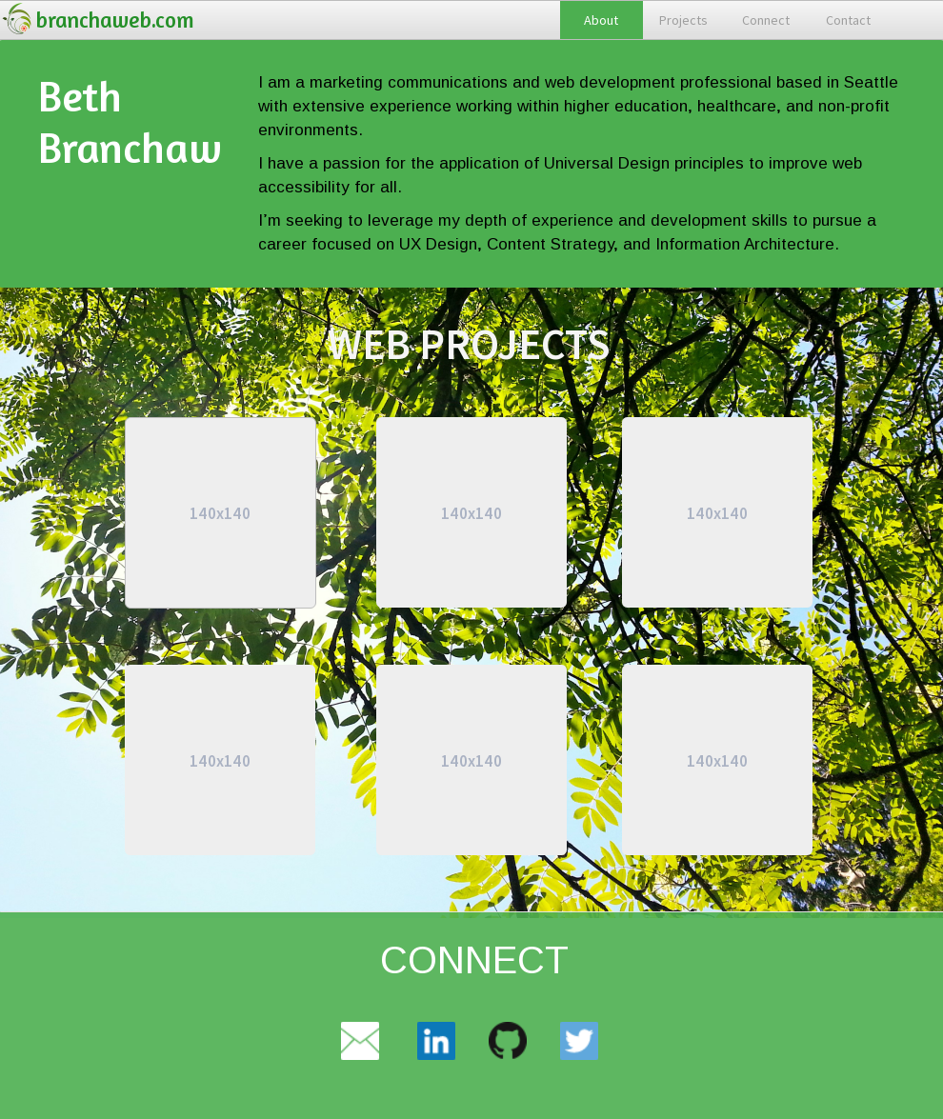
3. **Additional planning elements relevant to process or project**.
   1. Project information architecture—Outline of content and elements to be included:
      1. Logo for branchaweb.com
      2. Top navigation.
         1. About
         2. Projects
         3. Contact
         4. Connect
      3. Jumbotron with personal statement
      4. Projects
         1. Capstone project
         2. Rescue Finder
         3. The MixTape
         4. API Superstore
         5. Weather App
         6. User Science Journal
      5. Connect & Contact
         1. Email
         2. LinkedIn
         3. GitHub
         4. Twitter
      6. Footer
         1. Copyright 2017
         2. Contact: [branchaweb@gmail.com](mailto:branchaweb@gmail.com)
         3. Framework information
         4. CC license
   2. Artifact: Graphic selected for logo. (Creative Commons license).



* 1. Artifact: Primary image. Photo by Beth Branchaw.

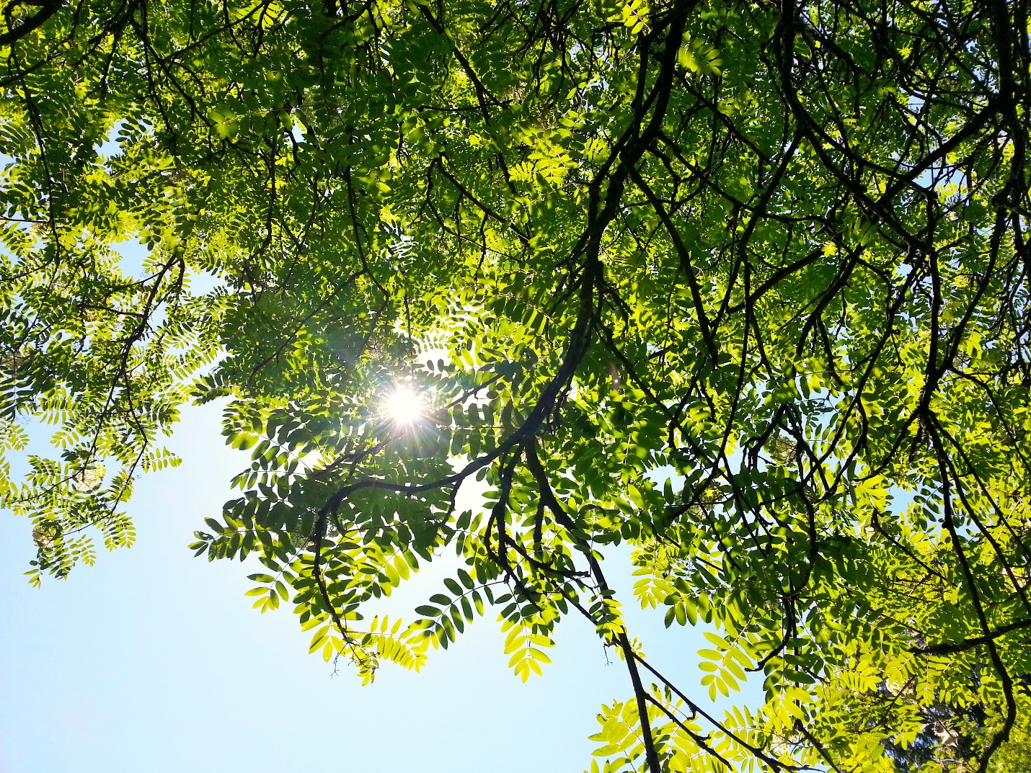

* 1. Artifact: Color palette

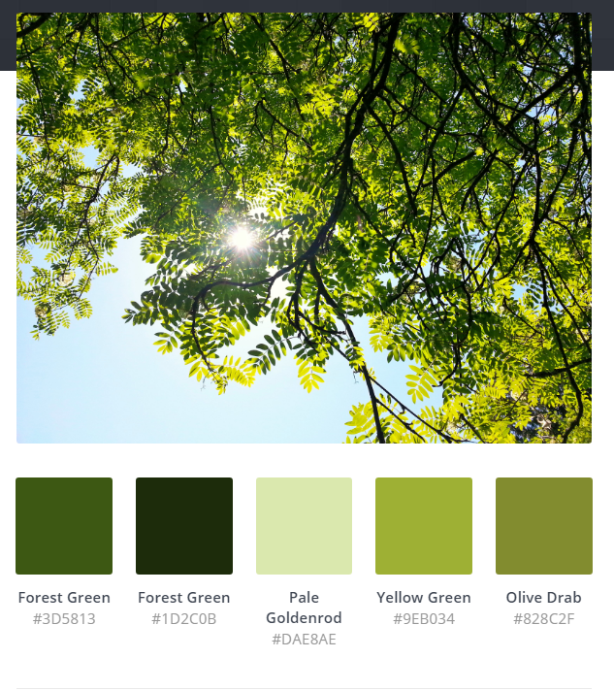

* 1. Artifact: Design comps/polished portfolio sites that inspire
     + - Denise Chandler <http://www.denisechandler.com/>
       - Ben Adam <http://benadam.me/>
       - Seb Kay <http://sebkay.com/>
       - Johnny MacEachern <https://jonny.me/>
       - Devin Walker <http://imdev.in/>
       - Pierre Nel <http://pierre.io/>